AI-Based Early Warning and Landslide Risk Monitoring System in NER
REPORT

1. Project Overview

The North Eastern Region (NER) of India — comprising Arunachal Pradesh, Assam, Manipur, Meghalaya, Mizoram, Nagaland, Sikkim, and Tripura — is among the most landslide-prone regions in the country due to its steep terrain, high monsoon rainfall, seismic activity, and expanding hill-slope construction. This project proposes an AI-based Early Warning and Landslide Risk Monitoring System that combines ground sensor networks, satellite and weather data, and machine learning models to detect early indicators of slope failure and issue timely alerts to residents, disaster management authorities, and infrastructure operators.
The system is designed as an end-to-end platform: field sensors and satellite feeds continuously stream data to a cloud backend, an ML risk-scoring engine evaluates slope stability in near real time, and a multi-channel alerting layer notifies stakeholders through a web dashboard, mobile app, SMS, and local sirens.

1.1 Problem Statement
Landslides in the NER cause significant loss of life, damage to roads and settlements, and disruption to connectivity every monsoon season. Existing warning mechanisms rely largely on manual field surveys and generalized regional rainfall thresholds, which are too coarse to predict site-specific slope failures with useful lead time. There is a need for a low-cost, scalable, and automated system that fuses multiple data sources and applies predictive modeling to generate localized, timely, and actionable warnings.

1.2 Objectives
- Continuously monitor rainfall, soil moisture, slope displacement, and vibration at landslide-prone sites.
- Fuse ground-sensor data with satellite (optical and InSAR) and weather-forecast data.
- Apply machine learning models to compute a real-time landslide risk score per monitored zone.
- Issue tiered early warnings (Advisory / Watch / Warning) to authorities and the public with sufficient lead time.
- Provide a web dashboard and admin console for disaster management authorities, and a mobile alert view for residents and field teams.
- Maintain a historical data and incident log to improve model accuracy over time.

1.3 Key Features
- Real-time sensor telemetry from rain gauges, soil-moisture probes, tilt meters, and geophones.
- Satellite-based ground-deformation tracking using InSAR imagery for wide-area slope monitoring.
- ML-based risk scoring combining rainfall intensity-duration thresholds with sensor and satellite features.
- Tiered alerting (Advisory, Watch, Warning) pushed via web, mobile app, SMS gateway, and sirens.
- Web dashboard with GIS-based risk maps, sensor health status, and historical trends.
- Mobile alert view for field officers and residents in monitored zones.
- Admin console for managing sensor networks, thresholds, users, and alert rules.
- Offline-tolerant edge gateways that buffer data during network outages common in hilly terrain.

2. System Architecture
The system follows a layered IoT-to-cloud architecture with four major tiers: field sensing, edge aggregation, cloud processing/ML, and presentation/alerting.

2.1 Architecture Overview
- Field Sensing Layer: Rain gauges, soil-moisture sensors, MEMS tilt meters, piezometers, and geophones deployed at monitored slopes; satellite feeds (optical + InSAR) for regional coverage.
- Edge Layer: Solar-powered LoRaWAN/NB-IoT gateways aggregate sensor readings locally, apply basic filtering, and buffer data during connectivity loss.
- Cloud / Processing Layer: Ingestion pipeline, time-series data store, feature engineering, and the ML risk-scoring engine; a rules engine converts risk scores into alert levels.
- Presentation & Alerting Layer: Web dashboard, mobile alert app, admin console, and multi-channel notification dispatch (push notification, SMS gateway, local siren trigger).

2.2 Data Flow
- Sensors sample readings at fixed intervals (e.g., rainfall every 5 minutes, tilt/vibration continuously with threshold-triggered upload).
- Edge gateways batch and transmit readings over LoRaWAN/NB-IoT/4G to the cloud ingestion endpoint, buffering locally if offline.
- The ingestion service validates, timestamps, and writes data to a time-series database, and streams it to the processing pipeline.
- Feature engineering computes rolling rainfall accumulation, rate-of-change of tilt/displacement, and soil-saturation indices.
- The ML risk-scoring model outputs a probability of slope failure per zone, which the rules engine maps to an alert tier.
- Alerts are dispatched to the dashboard, mobile app, SMS gateway, and (for Warning tier) local siren controllers, with full audit logging.

2.3 Tech Stack
Layer | Component | Suggested Technology
Field Sensing | Sensor nodes | Tipping-bucket rain gauge, capacitive soil-moisture probe, MEMS tilt sensor, geophone
Edge | Connectivity | LoRaWAN / NB-IoT gateway, solar power with battery backup
Ingestion | Data intake | MQTT broker, REST ingestion API
Storage | Time-series & spatial data | TimescaleDB / InfluxDB, PostGIS for GIS layers
Processing | Stream & batch pipeline | Apache Kafka, Apache Spark / Flink
ML | Risk-scoring engine | Python, scikit-learn, XGBoost / LSTM (TensorFlow or PyTorch)
Satellite | Ground deformation | Sentinel-1 InSAR, optical imagery (Sentinel-2 / PlanetScope)
Backend API | Application services | Node.js / Django REST Framework, GraphQL or REST

Web Dashboard | Frontend | React, Leaflet / Mapbox GIS visualization
Mobile App | Alert view | React Native / Flutter, push notifications (FCM)
Alerting | Notification dispatch | SMS gateway (e.g., Twilio-compatible), push notifications, siren relay controllers
Infra | Deployment | Kubernetes, Docker, cloud provider of choice (AWS / Azure / GCP)

3. Data Sources

3.1 Ground Sensor Network
- Rainfall: tipping-bucket rain gauges for intensity and cumulative rainfall.
- Soil moisture: capacitive probes at multiple depths to track saturation levels.
- Slope movement: MEMS tilt sensors and extensometers for surface displacement.
- Sub-surface pressure: piezometers for pore-water pressure buildup.
- Ground vibration: geophones to detect precursory micro-movements.

3.2 Satellite & Remote Sensing Data
- InSAR (e.g., Sentinel-1) for wide-area ground-deformation velocity mapping.
- Optical imagery for land-use change, vegetation loss, and slope-cutting detection.
- Digital Elevation Models (DEM) for slope angle, aspect, and drainage analysis.

3.3 Weather & Meteorological Data
- India Meteorological Department (IMD) rainfall forecasts and warnings.
- Nowcasting data for short-term (0–6 hour) rainfall-intensity prediction.

3.4 Historical & Contextual Data
- Past landslide incident records and geological survey data (e.g., Geological Survey of India landslide inventory).
- Soil type, lithology, and land-cover maps for static risk baseline.

4. Machine Learning Model

4.1 Modeling Approach
The system uses a two-stage modeling approach: a static susceptibility model that scores baseline landslide risk per zone using terrain and geological features, and a dynamic real-time model that adjusts risk based on live rainfall, soilmoisture, and displacement data.

4.2 Static Susceptibility Model
- Inputs: slope angle, aspect, elevation, land cover, soil/lithology type, drainage density, distance to fault lines, and historical incident density.
- Approach: Random Forest / Gradient Boosted Trees to classify zones into susceptibility classes (Low / Moderate / High / Very High).

4.3 Dynamic Real-Time Risk Model
- Inputs: rolling rainfall accumulation (1h/24h/72h), soil-moisture saturation, rate-of-change of tilt/displacement, pore-water pressure trend, and InSAR deformation velocity.
- Approach: Gradient-boosted trees for tabular features, combined with an LSTM/GRU sequence model over the sensor time-series to capture temporal precursor patterns.
- Output: a continuous failure-probability score (0–1) per monitored zone, recalculated at each ingestion cycle.

4.4 Alert Thresholding
Alert Tier | Risk Score Range | Action
Advisory | 0.20 – 0.45 | Logged and shown on dashboard; no push notification
Watch | 0.45 – 0.70 | Push notification to authorities and residents in zone
Warning | 0.70 – 1.00 | Push + SMS + siren activation; evacuation guidance issued
Thresholds are calibrated per zone using historical incident data and are reviewed periodically by domain experts to reduce false positives and false negatives.

4.5 Model Evaluation
- Metrics: Precision, Recall, F1-score, and lead-time-to-failure for historical validated events.Validation: time-based train/test split (not random split) to avoid data leakage across seasons.
- Continuous learning: model retrained periodically as new labeled incidents are logged through the admin console.

5. Alert Mechanism / Notification System
- Web dashboard: real-time GIS risk map with color-coded zones and drill-down sensor views.
- Mobile app: push notifications with zone-specific risk level and recommended action.
- SMS gateway: fallback channel for areas with limited smartphone/data connectivity.
- Local sirens: triggered automatically at Warning tier via relay controllers connected to edge gateways.
- Escalation workflow: unacknowledged Warning-tier alerts automatically escalate to district disaster management authorities after a configurable timeout.

6. Installation & Setup

6.1 Prerequisites
- Docker and Docker Compose (or Kubernetes cluster for production)
- Node.js 18+ and Python 3.10+
- PostgreSQL with PostGIS extension, TimescaleDB/InfluxDB
- MQTT broker (e.g., Mosquitto) for sensor ingestion

6.2 Setup Steps
- Clone the repository: git clone <repository-url>
- Copy .env.example to .env and configure database, MQTT broker, and SMS gateway credentials.
- Start core services: docker-compose up -d
- Run database migrations: npm run migrate (or the project's equivalent migration command) 5. Seed reference data (DEM, zone boundaries, historical incidents): npm run seed
- Start the backend API and ML inference service.
- Start the web dashboard: npm run dev (frontend directory)
- Build and deploy the mobile alert app using the provided React Native / Flutter project.

7. Usage

7.1 Web Dashboard
Disaster management staff log in to view a GIS map of all monitored zones, color-coded by current risk tier. Clicking a zone shows live sensor readings, rainfall trends, and the risk-score history for that location.

7.2 Mobile Alert View
Residents and field officers in registered zones receive push notifications when a zone transitions to Watch or Warning tier, along with recommended safety actions and evacuation routes where applicable.

7.3 Admin Console
Administrators manage sensor registration, calibrate alert thresholds per zone, configure notification recipients and escalation rules, and review historical incidents to support model retraining.8. Screenshots / UI
The following placeholders correspond to the three primary interfaces of the system. Replace these with actual application screenshots before final submission.8.1 Web Dashboard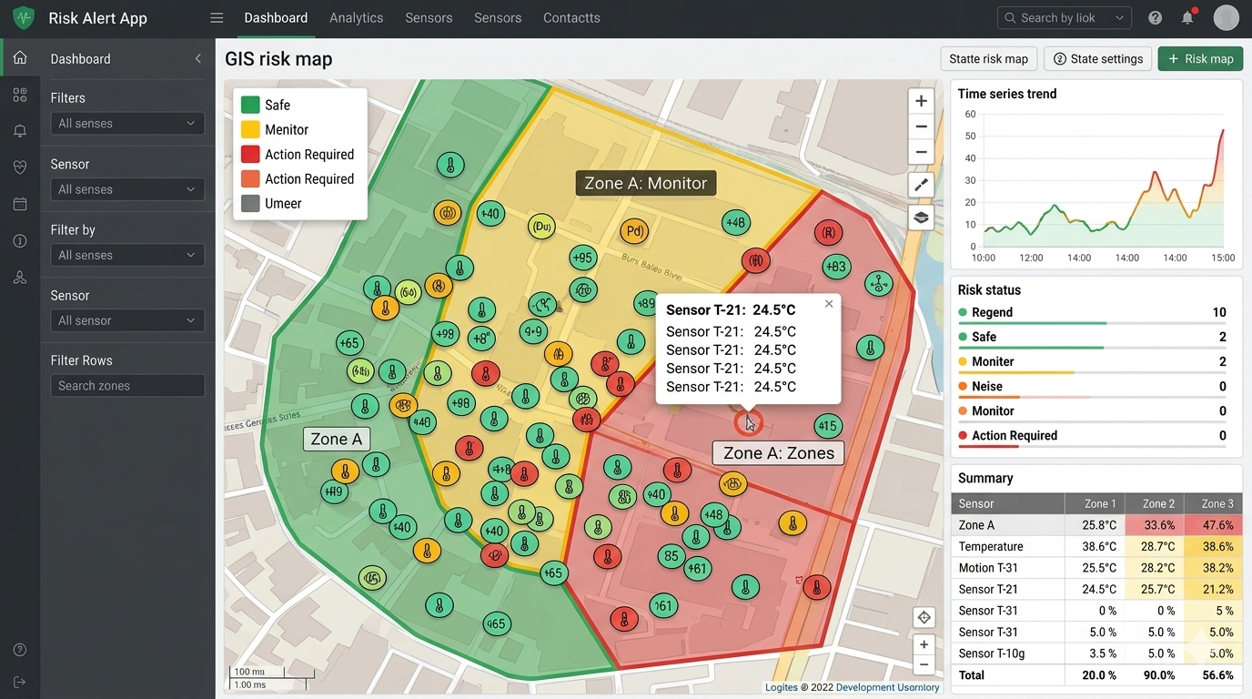
Web Dashboard — GIS risk map with zone status and sensor overlays
Figure 1: Web Dashboard

8.2 Mobile Alert View
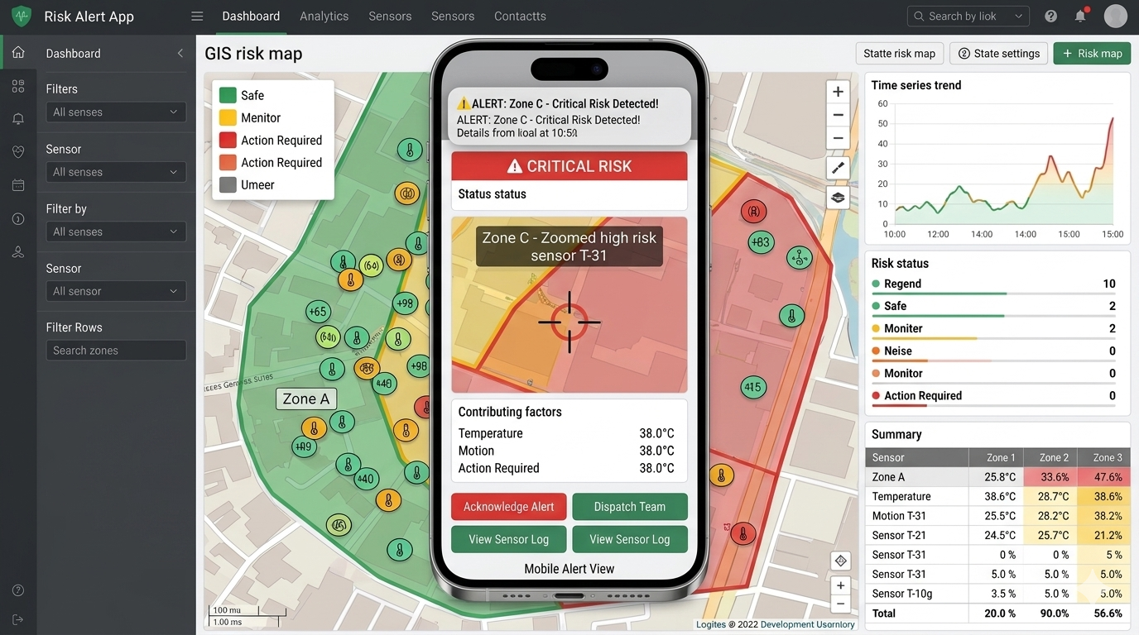
Mobile Alert View — push notification and zone risk detail screen
Figure 2: Mobile Alert View

8.3 Admin Console
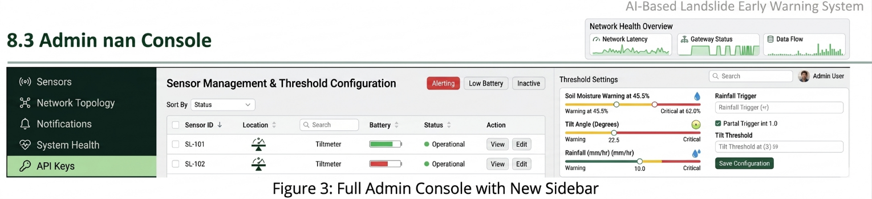
Admin Console — sensor management and threshold configuration
Figure 3: Admin Console

9. Testing

9.1 Unit Testing
- Sensor data validation and parsing functions tested with boundary and malformed-input cases.
- Risk-score computation functions tested against known reference inputs and expected outputs.

9.2 Integration Testing
- End-to-end pipeline tests from simulated sensor ingestion through to alert dispatch.
- Failover testing for edge-gateway offline buffering and delayed data sync.

9.3 Model Validation
- Backtesting the ML model against historical landslide events to measure lead time and false-alarm rate.
- Threshold sensitivity analysis across varying rainfall and soil-moisture scenarios.
9.4 Field Testing
- Pilot deployment at a small number of high-susceptibility slopes for real-world calibration before regional rollout.

10. Results & Evaluation
Pilot deployment results (illustrative, to be replaced with actual field data) demonstrate that combining rainfall thresholds with sensor-based displacement and satellite deformation data improves early-warning lead time compared with rainfall-only thresholds alone, while reducing false-alarm rates through zone-specific calibration.
Metric | Rainfall-Only Baseline | Multi-Sensor + ML System
Average lead time before failure | 2–4 hours | 6–12 hours
False-alarm rate | High | Reduced via zone calibration
Spatial resolution | District-level | Slope/zone-level

11. Challenges & Limitations
- Connectivity gaps in remote hilly terrain requiring robust offline buffering at edge gateways.
- Power reliability for field sensor nodes, mitigated via solar charging with battery backup.
- Limited historical labeled incident data for some zones, constraining initial model accuracy.
- Sensor maintenance and vandalism risk in remote locations.
- Balancing false-alarm rate against missed-event risk, given the high cost of both outcomes.

12. Future Scope
- Expand sensor coverage using low-cost, mass-deployable IoT nodes across additional high-risk corridors.
- Incorporate drone-based photogrammetry for periodic slope surveys.
- Integrate with state disaster management authority command-and-control systems for automated escalation.
- Community-reporting feature allowing residents to submit ground observations to supplement sensor data.
- Multilingual SMS and voice-call alerts to improve accessibility across the region's diverse linguistic groups.

13. Team / Contributors
[Add team member names, roles, and institution/organization here.]

14. References

- Geological Survey of India — National Landslide Susceptibility Mapping.
- India Meteorological Department — Rainfall and weather forecast data.
- European Space Agency (ESA) Copernicus Programme — Sentinel-1/2 satellite data.
- National Disaster Management Authority (NDMA), India — Landslide risk management guidelines.
[Add additional academic papers, datasets, and tools referenced during development.]

